Day-7=> 3-Tier Architecture Project Manual Configuration

- Install 3 linux server
  - DB Server
  - APP Server
  - Web Server
- Project url
  - expense-documentation/mysql.MD at main · daws-88s/expense-documentation · GitHub
- Let’s start configuring DB Server
- Install my sql server
  - $sudo su –
  - #dnf install mysql-server -y
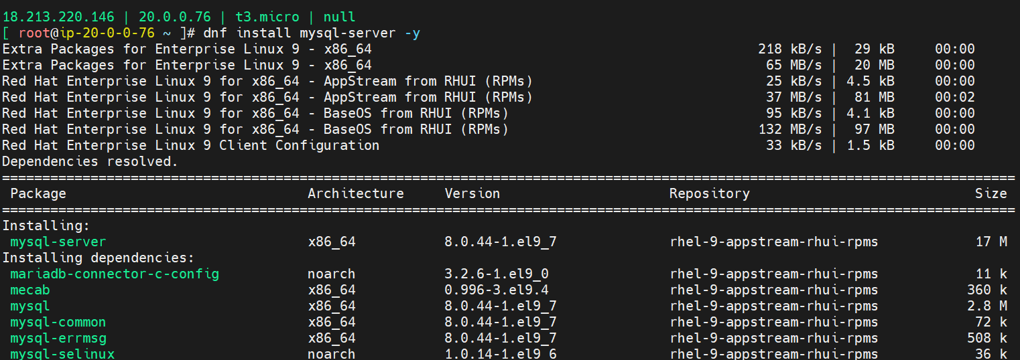
- $systemctl status mysqld
- $systemctl enable mysqld
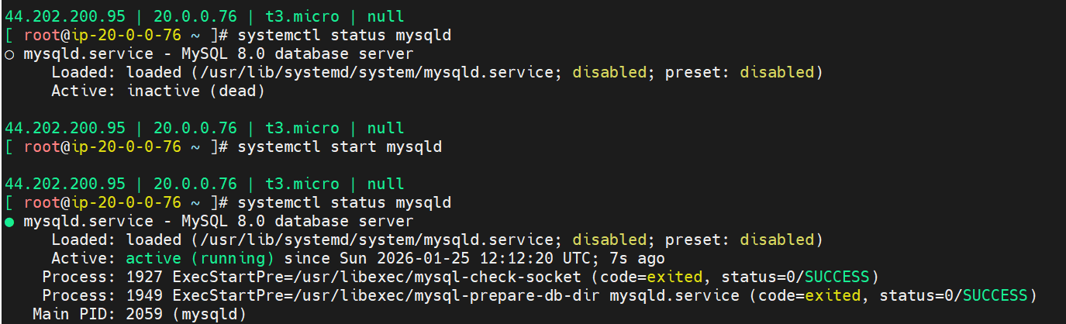
- $ps -ef | grep mysqld
- $netstat -lntp
- Default Username: root, port: 3306
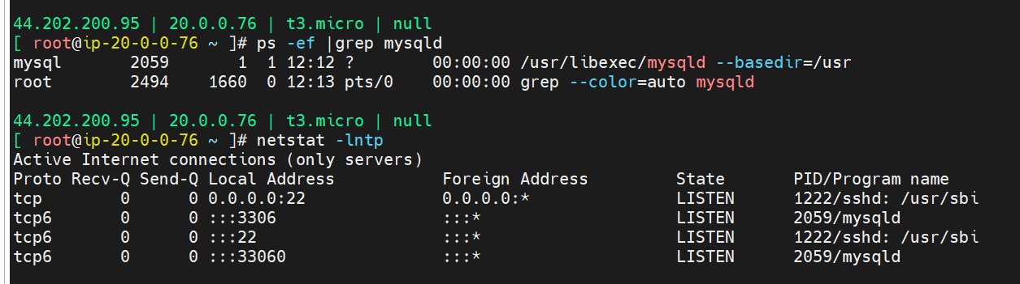
- Set password root user of mysqld
- $mysql_secure_installation –set-root-pass ExpenseApp@1
- $mysql -h <hostname> -p <password>

Lets connect to App server:
- Lets install NODEJS in server. First will check the latest versions list
- $dnf module list nodejs
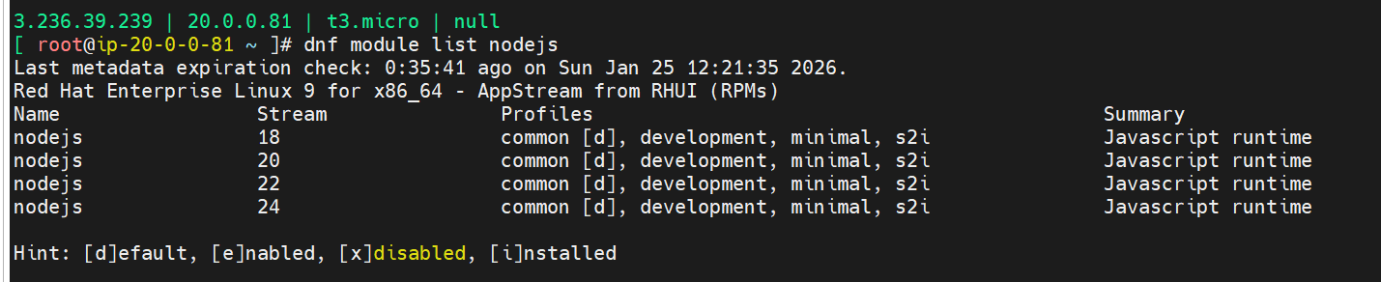
- In realtime, we never use latest version immediately after release. It is not best practice to use latest released version, better use 1 or 2 version legacy version to get more stability.
- So disabling default versions to select manually.
- $dnf module disable nodejs -y
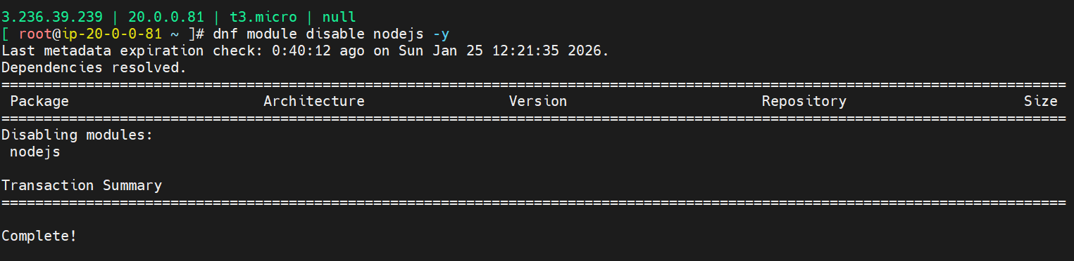
- lets enable 2 versions before software for better stability.
- $dnf module enable noejs:20 -y
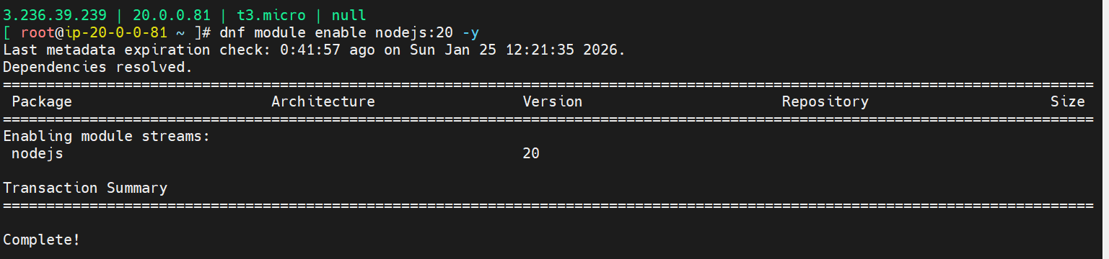
- Now install the Nodejs
- $dnf install nodejs -y
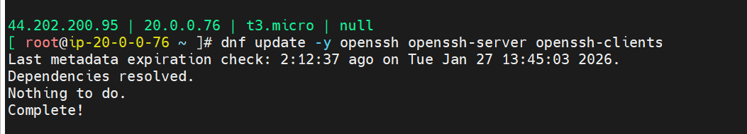
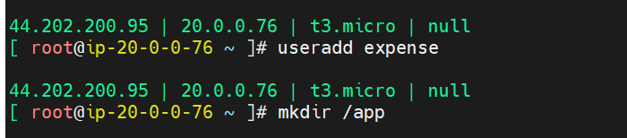

NodeJs extension -> .js
Libraries -> Dependencies
Package.json -> this is called build file where developers mention dependencies and application details.
NPM -> Node package Manager -> build tool
For python -> pip
.net -> nuget

NodeJs | Java | Python
.js | .java | .py
Package.json | Pon.xml | Requirements.txt
Npm | Maven | pip

Npm install -> reads package.json and download the dependencies from internet
All services are located in below path
- .service files -> /etc/system/system -> *.services
- systemctl start nginx -> /etc/systemd/system/nginx.service
